

SCHOOL OF ENGINEERING
Department of Artificial Intelligence and Machine Learning

CERTIFICATE
This is to certify that the Cornerstone project work entitled “ONLINE VOTING SYSTEM” is submitted by

A TEJASRI SAI SANTHOSH (24B11AI019)
D SWETHA (24B11AI087)
M CHITTI NAGA SAI (24B11AI228)
M SAI HARSHITH (24B11AI248)
in partial fulfillment of the requirements for the award of the B.Tech. degree in Artificial Intelligence and Machine Learning for the academic year 2025-2026.

Project Guide Head of the Department
S.Saikala , M.Tech , Ph.D, Dr. M. Venkatesh, M.Tech, Ph.D,
Assistant Professor, Associate Professor,
Department of AIML Department of AIML

DECLARATION

We hereby declare that the Cornerstone project entitled “ONLINE VOTING SYSTEM” is original and is submitted to ADITYA UNIVERSITY, Surampalem, in partial fulfillment of the requirements for the award of the B.Tech. degree in Artificial Intelligence and Machine Learning. We further declare that this project work has not been submitted, either in full or in part, for the award of any degree in this or any other institution. We also confirm that this work complies with the Institutional Academic Integrity and AI Usage Policy

Place: Surampalem
Date: 06-04-2026
By
A TEJASRI SAI SANTHOSH | (24B11AI019)
D SWETHA | (24B11AI087)
M CHITTI NAGA SAI  M SAI HARSHITH | (24B11AI228)  (24B11AI248)

ACKNOWLEDGEMENT

It is with immense pleasure that we express our sincere gratitude to our Cornerstone Project Guide, S.Saikala Assistant Professor, who has guided us throughout the project. His valuable support, encouragement, and guidance have greatly contributed to the successful completion of this work.
We would like to thank our Deputy Heads of the Department, Dr. R. Suneetha, Assistant Professor and Dr. A. Phani Sridhar, Assistant Professor, Department of AIML, for their support and valuable suggestions.
Our deepest thanks to our Head of the Department Dr. M. Venkatesh, Associate Professor,for his inspiration and for providing all the necessary facilities and resources required for this project.
We also extend our sincere thanks to Dr. M.V. Rajesh, Associate Dean, School of Engineering for their encouragement and support during the course of our project.
We would like to express our sincere gratitude to Dr.G.Suresh, Registrar, Dr. A Ramesh, Pro Vice-Chancellor (Engineering & Sciences), Dr. S. Rama Sree , Pro Vice-Chancellor (Academics), Dr .M. B. Srinivas, Vice -Chancellor, Dr. M. Sreenivasa Reddy, Deputy Pro Chancellor and Management, Aditya University for providing excellent infrastructure and state-of-the-art laboratories.
Finally, we would like to thank the faculty members, lab technicians, non-teaching staff, and our friends who have directly or indirectly supported us in completing this Cornerstone project successfully.

Index
Table of content | Page No
Introduction | 7
1.1 Introduction | 7
1.2 Problem Statement | 7
1.3 Objectives of the Project | 7
1.4 Scope of the Project | 7
System Overview | 8
2.1 Existing System | 8
2.2 Limitations of Existing System | 8
2.3 Proposed System | 8
2.4 Software Requirements | 8
2.5 Hardware Requirements | 8
Technologies Used | 9
Database Design | 10-12
4.1 Database Tables | 10
4.2 Table Structure | 10
4.3 Keys and Constraints | 11
4.4 Table Relationships | 11
4.5 Sample data/records | 11
5.System Modules | 13
6.Implementation | 14
7 Output Screens | 15-18
7.1 Login Screen | 15
7.2 Admin Dashboard | 15
7.3 Add Student Screen | 16
7.4 View Student Screen | 16
7.5 Room Allocation Screen | 17
7.6 Room Status Screen | 17
7.7 Fee Registration Screen | 18
8.Conclusion | 19
9.Future Enhancements | 20
10.References | 21
11.Appendix | 22-24

List Of Figures
S.no | Table Name | Page No
1 | Fig 7.1.1 User Login Screen | 15
2 | Fig 7.2.1 Admin Dashboard | 15
3 | Fig 7.3.1 Add Student Screen | 16
4 | Fig 7.4.1 View Student Screen | 16
5 | Fig 7.5.1 Room Allocation Screen | 17
6 | Fig 7.6.1 Room Status Screen | 17
7 | Fig 7.7.1 Fee Registration Screen | 18

List Of Tables
S.no | Table Name | Page No
1 | 4.2.1 Student Table | 10
2 | 4.2.2 Room Table | 10
3 | 4.2.3 Allocation Table | 10
4 | 4.2.4 Fee table | 11
5 | 4.5.1 Student Table Sample Record | 11
6 | 4.5.2 Room Table Sample Record | 11
7 | 4.5.3 Allocation Table Sample Record | 11
8 | 4.5.4 Fee Table Sample Record | 12
ONLINE VOTING SYSTEM
Abstract
The Online Voting System is designed to conduct voting electronically using a computer-based application. In traditional voting systems, ballot papers are used and votes are counted manually, which can be time-consuming and prone to human errors. The Online Voting System automates the entire voting process using a secure application built with Java and database connectivity.
This system allows voters to cast their votes digitally and ensures that each voter can vote only once. It also maintains candidate information and automatically counts votes, providing accurate and quick results. The system ensures transparency, security, and efficiency in the election process.
The Online Voting System can be used in colleges, organizations, and small-scale elections to simplify the voting process and eliminate manual work.

1. Introduction
1.1 Introduction
The Online Voting System is designed to conduct voting electronically using a computer-based application. In traditional voting systems, ballot papers are used and votes are counted manually, which can be time-consuming and prone to human errors. The Online Voting System automates the entire voting process using a secure application built with Java and database connectivity.
This system allows voters to cast their votes digitally and ensures that each voter can vote only once. It also maintains candidate information and automatically counts votes, providing accurate and quick results. The system ensures transparency, security, and efficiency in the election process.
The Online Voting System can be used in colleges, organizations, and small-scale elections to simplify the voting process and eliminate manual work.
1.2 Problem Statement
In many institutions and organizations, elections are conducted manually using ballot papers. This process involves several challenges such as maintaining voter lists, distributing ballot papers, and manually counting votes.
- Some common problems in the existing voting system include:
- Errors during vote counting
- Difficulty in maintaining voter records
- Time-consuming election process
- Possibility of duplicate voting
- Lack of transparency in the system
Therefore, a computerized system is required to improve efficiency, accuracy, and security in the voting process.
1.3 Objectives of the Project
- To automate the voting process
- To maintain voter and candidate information in a database
- To allow voters to cast their votes electronically
- To ensure that each voter can vote only once
- To automatically calculate voting results
- To provide quick and easy access to election results
1.4 Scope of the Project
The system can be used in:
- College elections
- University student council elections
- Organizational voting systems
- Club or association elections

The system simplifies the election process by providing an electronic platform where voters can cast votes easily and administrators can manage the entire process efficiently.

2. System Overview
2.1 Existing System
In the existing voting system, elections are conducted manually using ballot papers. Voters write or mark their choice on a ballot paper and drop it into a ballot box. After the voting process is completed, the election authorities manually count the votes to determine the winner.
This manual process requires a lot of effort and time. Maintaining voter records and managing ballot papers is also difficult and can lead to mistakes.

2.2 Limitations of Existing System
- High chances of human errors during vote counting
- Difficulty in managing large amounts of data
- Time-consuming voting and counting process
- Lack of efficient data management
- Possibility of duplicate or fraudulent voting
- No instant results after voting

2.3 Proposed System
The proposed system is a computerized Online Voting System developed using Java programming language. The system uses JDBC to connect the application with a MySQL database.
The application allows administrators to manage voters and candidates. Voters can log in to the system and cast their votes securely. Once a vote is submitted, it is stored in the database and counted automatically.
The system provides the following functionalities:
- Add voter records
- Add candidate details
- Allow voters to vote electronically
- Store votes in the database
- Display election results automatically
This system improves efficiency, reduces manual work, and ensures accurate vote counting.

2.4 Software Requirements
- Java JDK
- MySQL Database
- IDE (VS Code / NetBeans / Eclipse)
- Operating System (Windows/Linux)

2.5 Hardware Requirements
- Processor: Intel i3 or above
- RAM: 4 GB minimum
- Hard Disk: 10 GB free space

3. Technologies Used

3.1 Java (J2SE)
Java is used as the main programming language for developing the Online Voting System. It provides object-oriented programming features that help in building reliable and scalable applications.
3.2 Swing
Swing is used to create the graphical user interface of the application. It provides various components such as buttons, labels, text fields, and tables that allow users to interact with the system easily.

3.3 JDBC
JDBC (Java Database Connectivity) is used to connect the Java application with the
MySQL database.

3.4 Database
MySQL database is used to store all the data related to voters, candidates, and votes. It ensures that data is stored securely and can be accessed quickly when required.

4. Database Design
4.1 Database Tables
- Parties Table
- Voter Table
- Admin Table
4.2 Table Structure
Parties:
Field name | Data type | description
Party_name | VARCHAR | Party name
Votes | INT | No of votes to a party
Table 4.2.1 parties table
Admin Table:
Field Name | Data Type | Description
username | VARCHAR | Admin username
password | VARCHAR | Secret password to entry
Name | VARCHAR | Admin name
Phone | VARCHAR | Admin phone no
Person_id | VARCHAR | Admin id (primary)
Division | VARCHAR | Division belong
State | VARCHAR | State belong
Village | VARCHAR | Village belong
Table 4.2.2 Admin table
Voters table
Field Name | Data Type | Description
Voter_id | INT(PK) | Unique voter ID
name | VARCHAR | Name of voter
Village | VARCHAR | Belongs to
Gender | VARCHAR | Gender
Age | VARCHAR | Age
Has_voted | VARCHAR | Status
Table 4.2.3 Voters table
  - Keys and Constraints
1.Primary Key: person_id , voter_id
2.NOT NULL constraints for voter_id
3.Unique constraints for IDs
4.4 Table Relationships
The Lead Person table is connected to the Voters table through verification.
One lead person can manage multiple voters, and each voter is verified by one lead person.
The Voters table is connected to the Parties table through the voting process.
Many voters can vote for one party, but each voter can vote for only one party.
The Voters table is internally connected through voting status.
Each voter has a unique voter ID, and each voter can vote only once.
The Parties table is connected to the Voting system through vote count.
Each party can receive multiple votes, and the system updates the vote count after each vote.
The Lead Person table is connected to the System Dashboard.
One lead person can control and manage all operations like adding voters, viewing results, and monitoring voting.
The Voters table is connected to the Verification module.
Each voter must be verified using their voter ID before accessing the voting page.

4.5 Sample Data / Records
The following are sample records stored in the database tables of the Online Voting System.
Parties (Sample Records):
Party_name | Votes
Party A | 10
Party B | 4
Party C | 2
Table 4.5.1 parties sample record
Admin (Sample records):
Username | Password | Name | Phone | Person_id | Division | State | Village
Admin | 1234 | Ramesh | 987654321 | LP101 | A | Andhra Pradesh | Surampalem
Table 4.5.2 Admin sample record

Voters (Sample record):
Voter_id | Name | Village | Gender | Age | Has_voted
1 | Ravi kumar | Rampur | Male | 25 | voted
2 | Sita Devi | Rampur | Female | 30 | voted
3 | Swetha | Tekkali | Female | 19 | Not voted
Table 4.5.3 Voters sample record

5. System Modules
Module 1: Voter Registration Module
This module allows the administrator to add new voters to the system. The voter details are stored in the database.
Module 2: Candidate Management Module
This module allows the administrator to add and manage candidate details for the election.
Module 3: Voting Module
This module allows voters to cast their votes securely through the system.
Additional Modules:
- Voter Management Module
- Candidate Management Module
- Voting Module
- Result Management Module
- Login Module

6. Implementation
6.1 Database Connection
JDBC is used to establish a connection between the Java application and the MySQL database.

6.2 Input Validation
Input validation ensures that users enter valid data into the system. It prevents incorrect data entry and ensures that required fields are filled properly.

6.3 Exception Handling
- Handles database errors
- Handles invalid inputs
- Prevents system crashes

7. Output Screens
7.1 Login Screen:
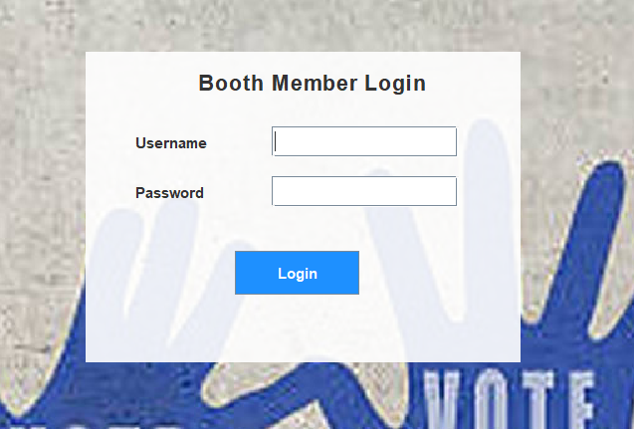
Fig 7.1.1: User Login Screen
This screen allows users to enter their login credentials such as username and password to access the voting system securely.
7.2 Admin Dashboard:
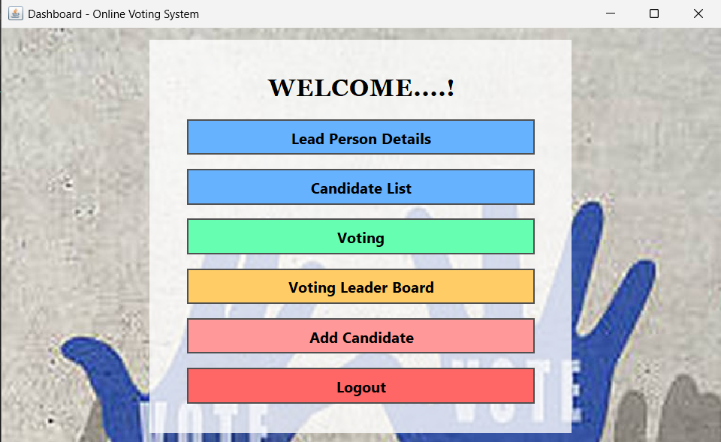
Fig 7.2.1: Admin Dashboard
The admin dashboard provides options to manage voters, candidates, and view election results. It acts as the main control panel of the system.
7.3 Booth Member details
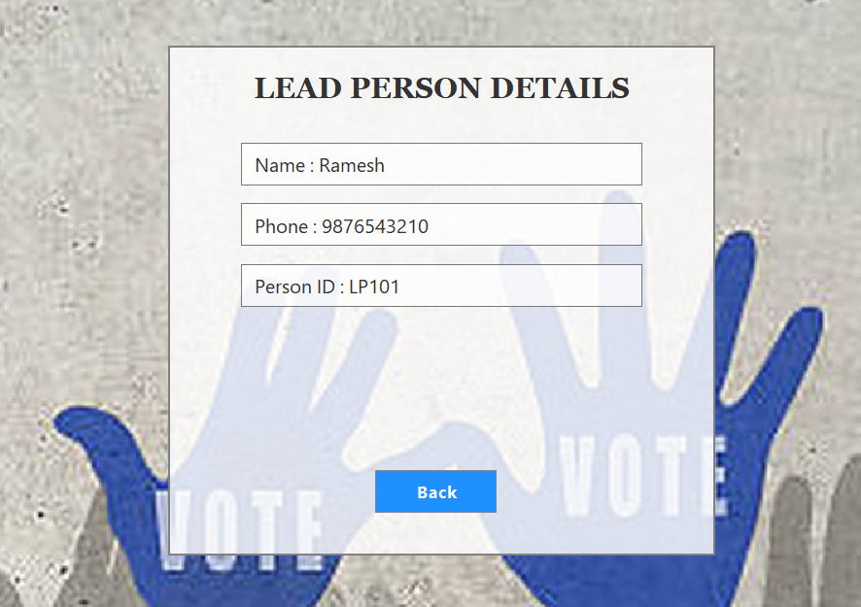
Fig 7.3.1: Booth member details
This page list out the booth member details contain name , phone number , person ID etc.
7.4 Voter list:
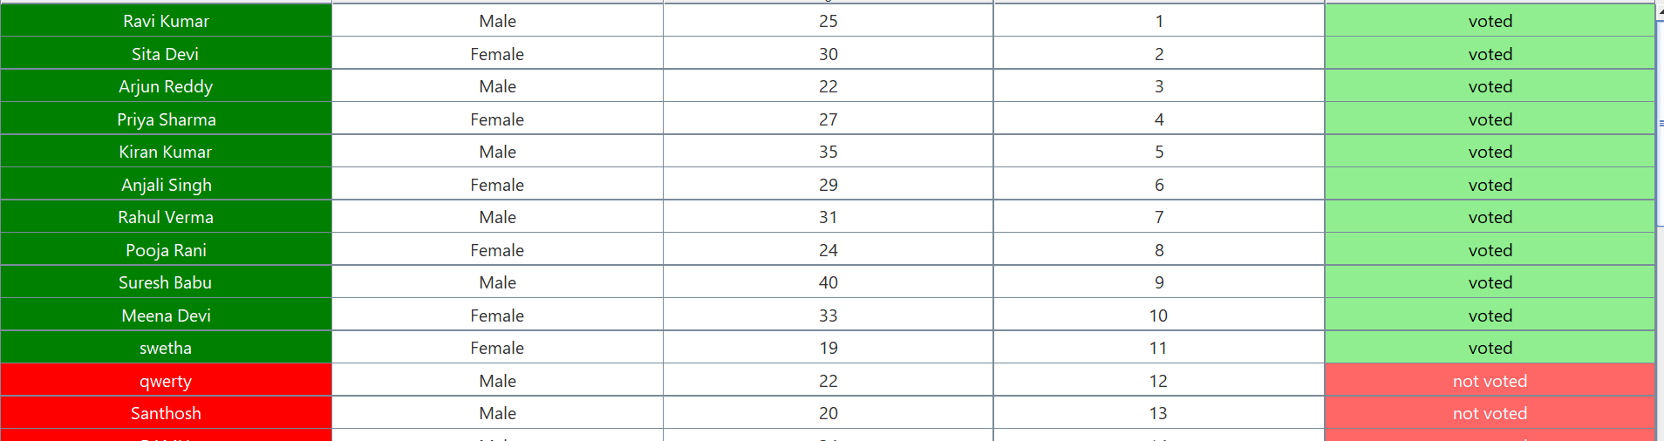
Fig 7.4.1: Voter list
This screen allows administration to visual the dataset contain with there status of “voted” or “not voted”.

7.5 Voting verification
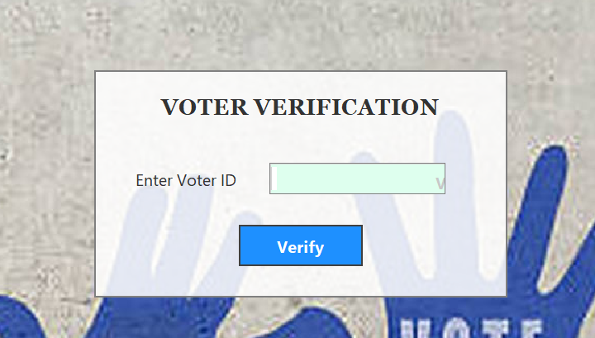
Fig 7.5.1 Room Allocation Screen
This screen allow to enter the voter id which is unique.
7.6 Leader board
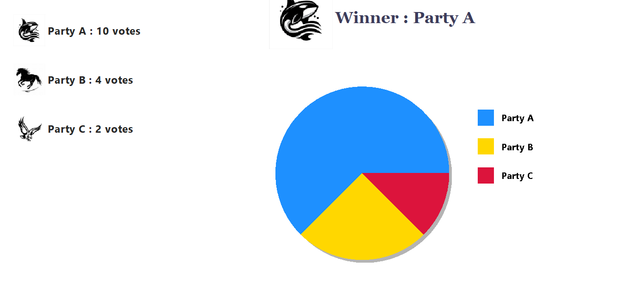
Fig 7.6.1: Leader board

This screen displays Winner among the parties participated.

7.7 Add new voter
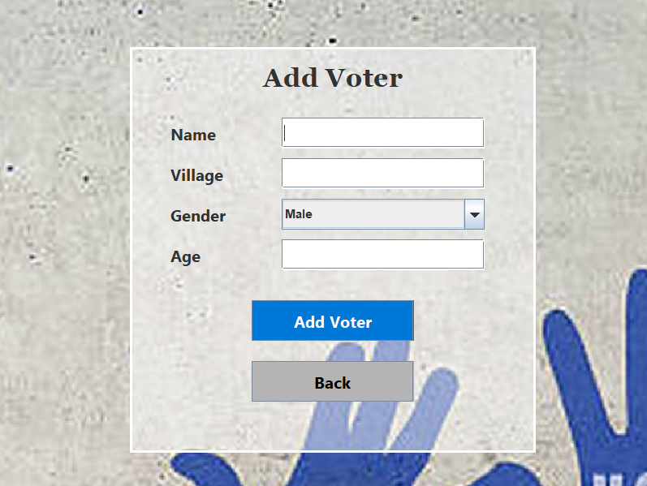
Fig 7.7.1 Register people for vote
This screen allow the administrator to add a new voter based on conditions which
need to have the age more than 18 if not more than one than it restrict and show a
pop message .

8.Conclusion
The Online Voting System project was developed to simplify and improve the voting process by replacing the traditional manual voting system with a computerized solution. In the traditional method, voting and counting of votes require a lot of time, effort, and are sometimes prone to human errors. By implementing this system, the entire process becomes faster, more accurate, and easier to manage.
This system stores all important information such as voter details, candidate details, and voting results in a database, which helps in maintaining records in an organized manner. It also ensures that each voter can vote only once, thereby reducing the chances of duplicate voting and improving the transparency of the election process.
The system provides a simple and user-friendly interface that allows administrators to manage voter registration, candidate information, and view election results easily. It also helps in reducing the use of paper, making the process more efficient and environment-friendly.
Through this project, we learned the practical implementation of Java programming, database connectivity, and application development. It also helped us understand the importance of system design, data management, and software development practices in solving real-world problems.
Overall, the Online Voting System provides a secure, reliable, and efficient platform for conducting elections in colleges, organizations, and other small-scale voting environments, ensuring that the election process becomes transparent, quick, and trustworthy.

9. Future Enhancements
Add Secure Voter Authentication:
A secure authentication system such as OTP verification or biometric authentication can be implemented to ensure that only authorized voters can access the system. This will help in improving the security and reliability of the voting process.
Convert into a Web-Based Application:
The system can be converted into a web-based application so that voters can cast their votes from any location using the internet, making the system more accessible and convenient.
Improve GUI Design:
The graphical user interface can be enhanced to make the system more attractive, user-friendly, and easy to navigate, improving the overall user experience.
Real-Time Result Display:
A feature can be added to display real-time voting results and statistics, allowing administrators to easily monitor the progress of the election.

10. References
1.Oracle–JavaDocumentation
https://docs.oracle.com/javase/tutorial/
(Used for understanding Java programming concepts and JDBC)
2.MySQLDocumentation
https://dev.mysql.com/doc/
(Used for database design and SQL queries)
3.GeeksforGeeks
https://www.geeksforgeeks.org/java/
(Used for Java programs, JDBC examples, and concepts)
4.W3Schools
https://www.w3schools.com/java/
(Used for basic Java and database connectivity tutorials)

11.Appendix
1. CONNECTION:
java
Connection con = DBConnection.getConnection();
2. Insert:
java
pst = con.prepareStatement("INSERT INTO students VALUES(?,?,?,?,?)");
pst.setInt(1,id); pst.setString(2,name);
pst.setInt(3,age); pst.setString(4,dept);
pst.setString(5,room);
pst.executeUpdate();
3. Select:
java
rs = con.prepareStatement("SELECT * FROM students").executeQuery();
while(rs.next()) System.out.println(rs.getInt("id"));
4. Update:
java
pst = con.prepareStatement("UPDATE students SET room_no=? WHERE id=?");
pst.setString(1,room); pst.setInt(2,id);
pst.executeUpdate();
5. Delete:
java
pst = con.prepareStatement("DELETE FROM students WHERE id=?");
pst.setInt(1,id);
pst.executeUpdate();

6. Login:
java
pst = con.prepareStatement("SELECT * FROM admin WHERE username=? AND password=?");
pst.setString(1,u); pst.setString(2,p);
if(pst.executeQuery().next()) JOptionPane.showMessageDialog(this,"Success");
7. Room check:
java
rs = pst.executeQuery();
if(rs.next() && rs.getInt(1)>=3) return;
8. Fee:
java
double bal = total - paid;
9. JTable:
java
model = new DefaultTableModel();
table = new JTable(model);
add(new JScrollPane(table));
10. Add Row:
java
model.addRow(new Object[]{id,name});
11. Delete Row:
java
int r = table.getSelectedRow();
model.removeRow(r);
12. Button:
java
btn.addActionListener(e -> method());

13. Frame:
java
setSize(400,300);
setVisible(true);
14. Navigation:
java
new Dashboard(); dispose();

